**MINI PROJECT REPORT**

**ON**

**FACE DETECTION USING PYTHON**

**B. Tech**

IN

**Computer Science and Business Systems**

**Submitted By**

|  |  |
| --- | --- |
| **Name** | **Univ. Roll No.** |
| Satyam Kr Mallick | 10831120005 |
| Sushmita Dhar | 10831120006 |
| Rounak Baishakhiyar | 10831120008 |
| Akash Yadav | 10831120011 |
|  |  |

**Under the supervision of:**

**Mrs. Shatabdi Saha**

Assistant Professor

Department of Computer Science



**DEPARTMENT OF COMPUTER SCIENCE AND ENGINEERING**

**ASANSOL ENGINEERING COLLEGE**

**AFFILIATED TO**

**MAULANA ABUL KALAM AZAD UNIVERSITY OF TECHNOLOGY**

April, 2022

***Contents***

|  |  |  |  |
| --- | --- | --- | --- |
| Certificate of Recommendation……………………………………………………………… | | | iii |
| Certificate of Approval………………………………………………………………............. | | | iv |
| Acknowledgement…………………………………………………………............................ | | | v |
| Abstract…………………………………………………………………………...………….. | | | vi |
| List of Figures………………………………………………………………………………. | | | vii |
|  | | |  |
|  | | |  |
| **1.** | **Introduction** | |  |
|  | 1.1 | Problem Definition……………………………………………...……………..... | 1 |
|  | 1.2 | Motivation of the project………………………………….…………………....... | 1 |
|  | 1.3 | Basic description of the project………………………….……………………..... | 1 |
| **2.** | **Literature Review** | |  |
|  | 2.1 | Review of related works …………………………. …………......….…...…….... | 2 |
| **3.** | **Related Theories and Algorithms** | |  |
|  | 3.1 | Fundamental theories underlying the work.…………………………………....... | 3 |
|  | 3.2 | Fundamental algorithms………………………………….…………………….... | 3 |
| **4.** | **Proposed model/algorithm** | |  |
|  | 4.1 | Proposed model………………………………………………………………...... | 4 |
|  |  |  |  |
| **5.** | **Simulation Results and Performance analysis** | |  |
|  | 5.1 | Experimental set up ……………………………………………..…………........ | 5 |
|  | 5.2 | Experimental results………...……………...……................................................ | 5 |
|  |  |  |  |
| **6.** | **Conclusion and Future Scope** | |  |
|  | 6.1 | Conclusion…………………………………..………………………….……...... | 7 |
|  | 6.2 | Future work…………………………………..….……………………...……..... | 7 |
|  | | |  |

|  |  |
| --- | --- |
|  | **DEPARTMENTOF COMPUTER SCIENCE AND ENGINEERING** |
| **ASANSOL ENGINEERING COLLEGE**  Vivekananda Sarani, Kanyapur, Asansol, West Bengal – 713305 |

***Certificate of Recommendation***

I hereby recommend that the preliminary project report entitled, **“Real time face detection using Python”** carried out under my supervision by the group of students of Bachelor of Technology in Computer Science and Engineering of Asansol Engineering College under MAULANA ABUL KALAM AZAD UNIVERSITY OF TECHNOLOGY.

|  |  |
| --- | --- |
| **Name** | **Univ. Roll No.** |
| Satyam Kr Mallick | 10831120005 |
| Sushmita Dhar | 10831120006 |
| Rounak Baishakhiyar | 10831120008 |
| Akash Yadav | 10831120011 |
|  |  |

_______________________

**Mrs. Shatabdi Saha**

Project Supervisor

Department of Computer Science and Engineering

Asansol Engineering College

Asansol – 713305

________________________

Countersigned:

**Dr Pintu Pal**

Head of the Department

Dept. of Computer Science and Business Systems

Asansol Engineering College,

Asansol-713305

|  |  |
| --- | --- |
|  | **DEPARTMENTOF XXX ENGINEERING** |
| **ASANSOL ENGINEERING COLLEGE**  Vivekananda Sarani, Kanyapur, Asansol, West Bengal – 713305 |

***Certificate of Approval***

The forgoing thesis is hereby approved as creditable study of an engineering subject carried out and presented in a manner satisfactory to warrant its acceptance as prerequisite to the degree for which it has been submitted. It is understood that by this approval the undersigned does not necessarily endorse or approve any statement made, opinion expressed or conclusion drawn therein but approve the thesis only for the purpose for which it is submitted.

_______________________

**Mrs. Shatabdi Saha**

Project Supervisor

Department of Computer Science and Engineering

Asansol Engineering College

Asansol – 713305

***Acknowledgement***

It is our great privilege to express our profound and sincere gratitude to our Project Supervisor, **Mrs. Shatabdi Saha** for providing us a very cooperative and precious guidance at every stage of the present project work being carried out under his/her supervision. His valuable advice and instructions in carrying out the present study has been a very rewarding and pleasurable experience that has greatly benefited us throughout the course of work.

We would like to convey our sincere gratitude towards **Dr Pintu Pal**, Head of the Department of Computer Science and Business Systems, Asansol Engineering College for providing us the requisite support for timely completion of our work. We would also like to pay our heartiest thanks and gratitude to all the teachers of the Department of Computer Science and Engineering, Asansol Engineering College for various suggestions being provided in attaining success in our work.

Finally, I would like to express my deep sense of gratitude to my parents for their constant motivation and support throughout my work.

…………………………………

Satyam Kumar Mallick

…………………………………

Sushmita Dhar

…………………………………

Rounak Baishakhiyar

…………………………………

Akash Yadav

***Date: 18/04/2022***

***Place: Asansol***

Abstract

Image detection is spreading its wings in all possible domains. Data analysis, security, Image processing and many more to mention. We as beginner wanted to use the python libraries and were fascinated by the object detection using python. We gathered the knowledge from wherever possible and implemented it. We used the OpenCV library available for python along with the Haar Cascade classifier to detect the human face as soon one is detected in the scene. Our Project detects the face in real time, that is why we used the Haar Cascade. The coding language Python also proved very useful. The results were as expected. Our code ran successfully and the computer was able to detect the faces. One thing which we could conclude from the project is that Haar Cascade is not able to detect the human faces besides the frontal face. The project was completed in time and was highly informative to our team.

***List of Figures***

|  |  |  |
| --- | --- | --- |
| Fig. 2.1 | 2.1.B | ix |
| Fig. 5.2 | 5.2.A | xii |
| Fig. 5.2 | 5.2.B | xiii |
| Fig. 5.2 | 5.2.C | xiii |

1. **Introduction**
   1. **Problem Definition**

**Using camera of the device (PC) identify one or more human faces.**

* 1. **Motivation of the project**

**The motivation of the project is actually the fact that how face detection is the beginner stage for the following- Face Analysis, Face tracking and face recognition.**

**Real time face detection is applicable in many other domains.**

* 1. **Basic description of the project**

**Our project Real time face detection using Python uses the PC camera and identifies all different human faces present in the screen. It is a very beginning stage of face detection.**

**The face detection using Python uses OpenCV of Machine learning to search for faces within a scene.**

**OpenCV is in fact one of the most popular and probably one of the simplest way to detect faces using python. The algorithms break the task of identifying the face into thousand of smaller, byte-sized tasks, each of which is easy to solve using a classifier.**

**Our project also uses Haar Cascade which is an Object Detection Algorithm used to identify faces in an image or a real time video.**

1. **Literature Review**
   1. **Review of related works**

**It is known that OpenCV widely used to operate on images and has a wide variety of applications. But there are other methods by which we can attain the objective.**

**Let us review such methods.**

1. **Image scaling(using Nearest Neighbour Interpolation):**

**Nearest neighbour interpolation is the simplest way of interpolation. This method simply determines the “nearest” neighbouring pixel and assumes the intensity value of it.**

**Consider a small image which has ‘w’ pixels of width and ‘h’ pixels of length.**

**We want to re-size to ‘p’ pixels wide by ‘q’ pixels high.**

**We assume p>w and q>h.**

**scale_x =p/w**

**scale_y =q/h**

**We simply loop through all the pixels in the output of the image, addressing the source pixels to copy from by scaling our control variables by scale_x and scale_y, and rounding the resulting scaled index values.**

1. **Pictorial Representation:**

**Image of 3X3 pixel (total 9 pixels), now if we want to increase the size of image up to 6X6 then, according to the nearest neighbouring algorithm 6/3 (i.e. 2) pixels should have the same RGB value as that of the pixel in original image.**

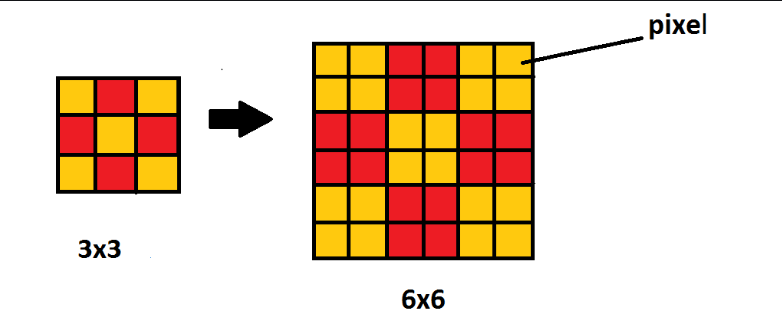

1. **Dlib Frontal Face Detector**

**Dlib is a C++ toolkit containing machine learning algorithms used to solve real-world problems. Although it is written in C++ it has python bindings to run it in python. It also has the great facial landmark key point detector.**

**The frontal face detector provided by dlib works using features extracted by Histogram of Oriented Gradients (HOG) which are then passed through an Support Vector Machine(SVM).**

**It provides a more advanced CNN based face detector.**

1. **Related Theories and Algorithms.**
   1. **Fundamental theories underlying the work**

**Object detection is a computer technology related to computer vision in which image processing and deep learning methodologies are applied that deals with the detection of the objects which is captured in the view port of images and videos.**

**OpenCV is a huge open-source library for computer vision, machine learning, and image processing. OpenCV supports a wide variety of programming languages like Python, C++, Java, etc. It can process scenes of images and videos to identify objects, faces, or even the handwriting of a human.**

**When OpenCV is integrated with other libraries such as Numpy, which is very optimized library for other numerical operations.**

**OpenCV is open-source library that includes several hundreds of computer vision algorithms. It has a modular structure, which means that the package includes several shared or static libraries. There are mainly modules are available:**

* **Core functionality (core)**
* **Image Processing (imgproc)**
* **Video Analysis (video)**
* **Camera Calibration and 3D Reconstruction (calib3d)**
* **2D Features Framework (features2d)**
* **Object-Detection (objdetect)**
* **High-level GUI (highgui)**
* **Video I/O (videoio)**
  1. **Fundamental Algorithms**

**Haar Cascade classifiers are an effective way to detect images. This method was proposed by Paul Viola and Michael Jones in their paper Rapid Object Detection using a Boosted Cascade of Simple Features. It is a machine learning model where a lot of positive and negative images are used to train the classifier.**

* **Positive images: These images contain those images which we want the classifier to identify.**
* **Negative Images: Images of everything else which do not have the object we want to detect.**

**Haar Cascades can be used to detect any types of objects, But you must have the appropriate XML file for it. Furthermore, this algorithm can run in real-time making it useful to detect the objects in the video scenes captured through the Computer vision. One can design their own XML files from scratch to detect their desired objects.**

**The only disadvantage of Haar Cascade is that it is best suited for frontal image detection. It will probably fail in the other cases.**

1. **Proposed Model**
   1. **Proposed Model**

**import cv2**

**cap=cv2.VideoCapture(0)**

**classifier=cv2.CascadeClassifier("haarcascade_frontalface_default.xml")**

**while True:**

**ret,frame=cap.read()**

**if ret:**

**faces=classifier.detectMultiScale(frame)**

**for face in faces:**

**x,y,w,h=face**

**frame=cv2.rectangle(frame,(x,y),(x+w,y+h),(0,255,0),6)**

**cv2.imshow("my windows",frame)**

**key=cv2.waitKey(1)**

**if key==ord("q"):**

**break**

**cap.release()**

**cv2.destroyAllWindows()**

1. **Simulation Results and Performance analysis**
   1. **Experimental Setup**

**The project requires a computer with Python installed in it.**

**The python installed must have OpenCV library so that it can be imported.**

**Along with this we require the Haar Cascade classifier XML file.**

**The above requirements will result fruitful only when the computer has camera device connected to it as the project is based on real time face detection.**

* 1. **Experimental Results**

**The Experimental results are above satisfactory. The computer is able to detect the human face present on the scene.**

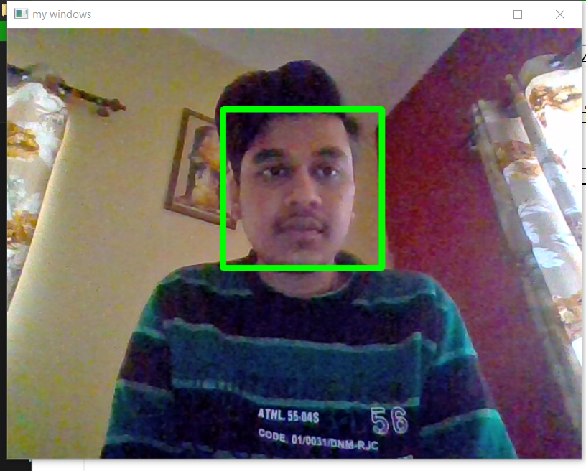

**Since the classifier is best suited for frontal face detection, it was observed that it the computer was unable to detect the same human face with its side profile.**

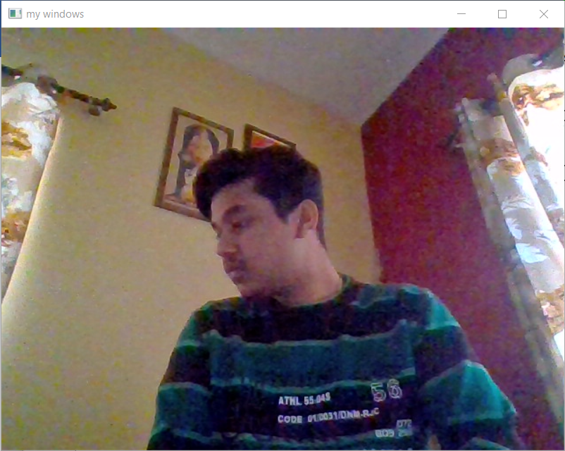

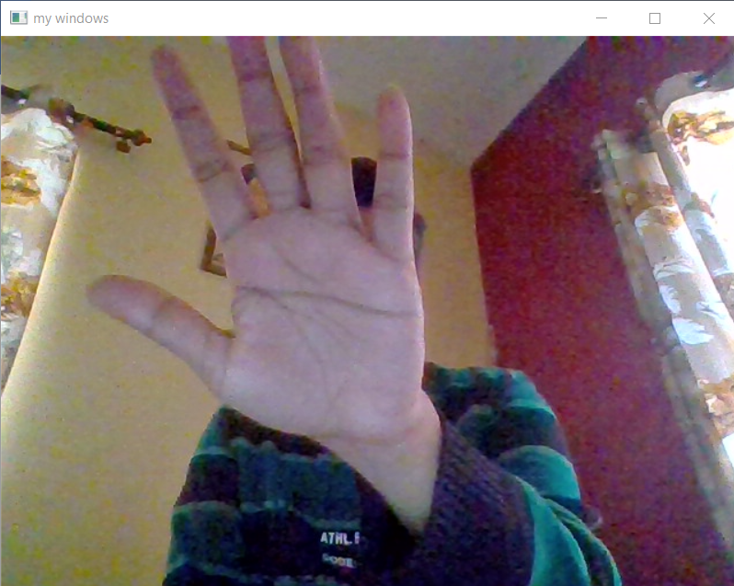

1. **Discussion and Conclusions**
   1. **Conclusion**

**My team and myself are now able to find faces in the images. We were able to learn to represent regions in a scene with Haar Cascade classifier and its features. We learnt a lot as a team and also came across the wide application of python programming in the field of image processing. We want to express our sincere gratitude to our Head of Department and Mentor.**

* 1. **Future Work**

**The future work of face detection is face recognition. We can distinguish different faces based on the features stored in the database. Face Recognition is useful in the domain of security. Find and track criminals. For surveillance purpose. It is even applicable in Banking and retail, Health sector.**